Moses Sanchez

Professor Yu

**Assignment 4.1**

**Graph Builder**

**High school GPA vs. Gender**

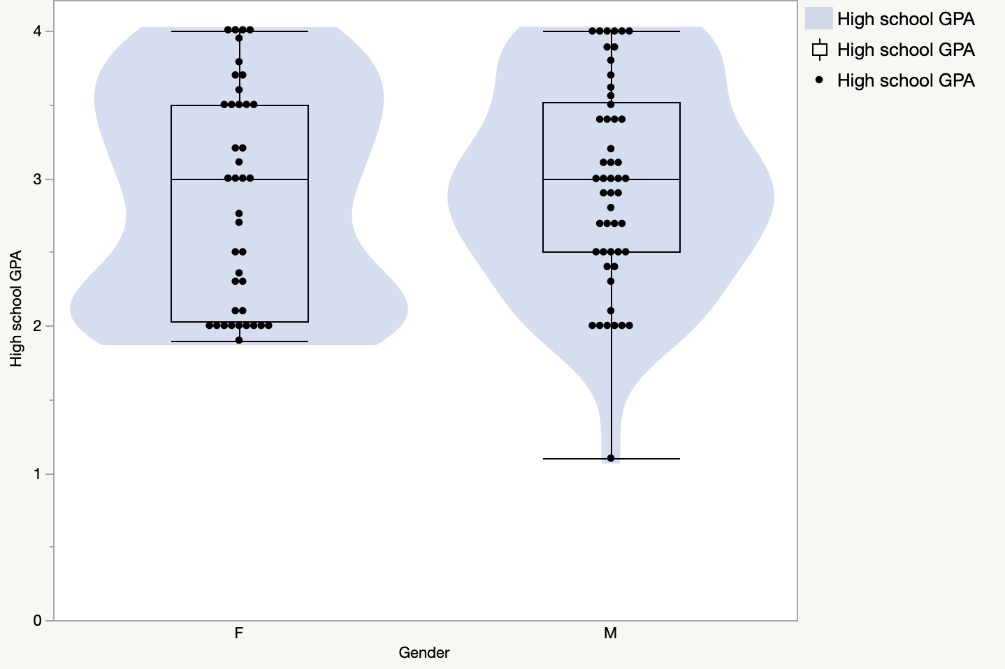

For the female distribution in the violin plot, it was more frequent that they had a GPA greater than 3.5 followed by a GPA less than 2.5. A 3.0 GPA was the least frequent. In the male distribution, the frequency for each GPA is almost the same width. It looks like a 3.0 GPA is the most frequent followed by a GPA less than 3.0 being the next most frequent. A GPA greater than 3.5 is the least frequent. From the female quartile, there is a minimum GPA of around a 1.9. Most of the datapoints are in the lower quartile (2.0). The median is a 3.0 GPA, and it has the fewest points. Between the upper quartile (3.5) to the maximum (4.0) is the second most results. From the male quantile, the minimum GPA is a 1.0. From the minimum to the lower quartile (2.5), the frequency increases. From the lower quantile to the median (3.0), the frequency continued to increase. The median had the most frequency. From the median to the maximum (4.0), the frequency decreases.